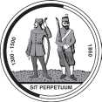2017 Trade Membership Application

National Rifle Association Bisley National Shooting Centre Brookwood Surrey GU24 0PB  
Tel: 01483 797777 Ext 138 Fax: 01483 797285 Email: [nick.halford@nra.org.uk](mailto:nick.halford@nra.org.uk)

Please read carefully and complete legibly

**Company Name:**

|  |  |
| --- | --- |
| Mr/Mrs/Miss/Ms/Other  Full Name | Tel: Home No |
| Address | Tel: Work No |
|  | Mobile No |
|  | Occupation & Description (ie Manager/Telecoms) |
| Post Code |  |
| Email Address |  |

Please give company details (in not more than 50 words) for your free entry in the NRA Journal

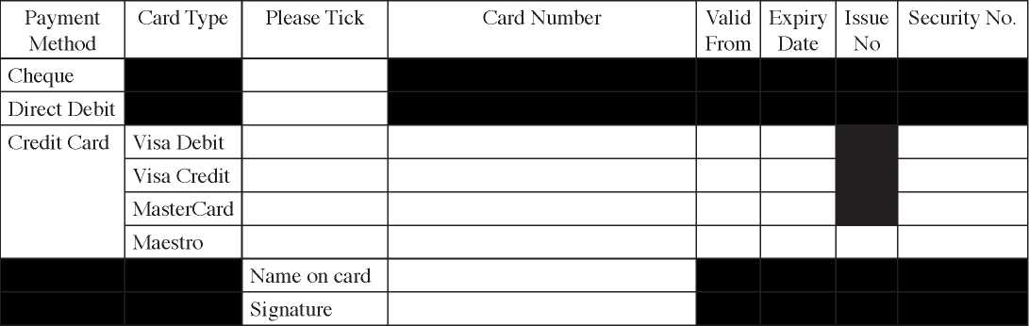

**2017 Fees**

Annual Non-Shooting Trade Membership £107 (inc. VAT) Yes/No *(delete as appropriate)*

Annual Shooting Trade Membership £356.65 (inc. VAT) Yes/No *(delete as appropriate)*