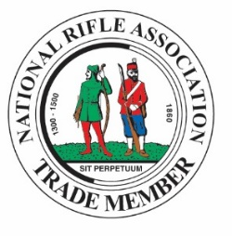
TRADE MEMBERSHIP OPTIONS 2017

NON-SHOOTING Trade Membership
The National Rifle Association non-shooting Trade Membership offers businesses a ‘one stop’ communication portal to over 8000 individuals, 850 clubs and their members.
Non-shooting membership is designed to support your existing marketing plan and help generate extra leads and increase your sales for far less than the price of a half page ad! For only £107 inc VAT per year NRA trade members can take advantage of the following:
- Company website link and description on dedicated supplier page on the NRA website which receives over 2000 hits per month.
- NRA ‘trade member’ logo can be used on member’s website, stationary and marketing material showing your continued support for the sport.
- Free listing in the quarterly NRA Trade Journal.
- Reduced trade area rates at NRA competitions
- Reduced advertising rates in NRA competition publications
- NRA sponsorship opportunities ranging from training days to meeting and events.

SHOOTING Trade Membership 2017
Trade Members who wish to take advantage of being able to use the Bisley ranges can do so for £356.65 inc VAT per annum.
Benefits of Shooting Trade Membership include the same as a non-shooting Trade Member, as well as the opportunity to book targets at Bisley at NRA member rates. The following terms apply:
- Booking ranges can only be made through the Shooting Trade Membership, and not individual memberships
- Each booking must be supervised by an NRA RCO
- Shooting Trade Member must sign statement to confirm that their shooting activity is fully compliant with UK Firearms Law, Home Office Guidance and Bisley Range Regulations
- Each shooter must have NRA SCC or be supervised one to one by a holder of an NRA SCC
- Shooting Trade Members must provide the NRA with a copy of their insurance certificate proving £10m Public Liability cover
How to get started
Complete the agreement form agreeing to the terms and conditions and return to the Membership Department, National Rifle Association, Bisley Camp, Brookwood, Surrey GU24 0PB

