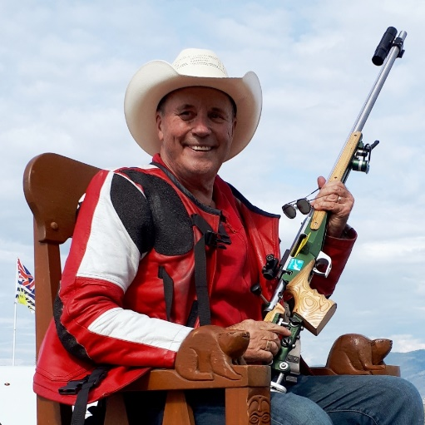

Capt. Robert (Bob) Pitcairn,
June 26, 1938 - March 4, 2022.

It is with heavy hearts that we announce the passing of Capt. Robert (Bob) Pitcairn on Friday, March 4, 2022 in Chilliwack, B.C. at the age of 83 years. A broken collarbone that happened last summer healed slowly and then rapidly progressed into a battle with bone cancer, which was only diagnosed shortly before he “Flew West” as pilots say.

Robert (Bob) Pitcairn was born in Summerside, PEI in 1938 to parents Scotty & Muriel Pitcairn, along with eldest sister Myrna and younger brother Donald. He spent five years in Air Cadets, receiving his Private Pilot license and Cadet Wings. He joined the RCAF in London, ON in 1956 before moving to the Prairies to fly a wide variety of military jets and meeting his future wife Kay in Portage la Prairie, MB. Declining a Permanent Commission in the RCAF, Bob and Kay along with their young children moved to Richmond in 1966. There Bob joined Canadian Pacific Airlines and started flying the DC-3 and DC-8, ending his flying career at the controls of a Boeing 747-400 in 1998. With 24,160 hours of flying time, Bob’s most challenging trip was in Nov. 1974 when he was hijacked in a CP Air 737 that landed safely in Saskatoon, SK.

Bob Pitcairn was a legend in Fullbore Target Rifle shooting that he took up in 1960 and competed in successfully for six decades. He qualified for a record 45 Canadian Bisley Teams to the NRA of the UK National Matches and 13 ICFRA World Palma Long Range Teams. Along the way he won more than 180 first place championship awards in provincial, national and international competition. Bob has been inducted to the Prince Edward Island, Dominion of Canada Rifle Association and Canadian Forces Sports Halls of Fame. The pinnacle of his sporting life was when he represented Canada at the Gold Coast 2018 Commonwealth Games in Australia, where he set the record for the oldest competitor ever at the age of 79 years and 9 months.

Bob is survived by his loving wife of 62 years Kay, daughter Lee-Anne, son Don, grand-daughters Sarah and Denise plus his sister Myrna Babineau in PEI. A Celebration of Life ceremony is being held at 2 P.M. on April 30, 2022 in the “Evergreens at Ensley” strata clubhouse located at 45900 South Sumas Road, Chilliwack. If you plan on attending his service, please RSVP your intentions to pilotshot@telus.net. In lieu of flowers, the Pitcairn family asks that you consider a donation to the BC Cancer Foundation or the Cascades Hospice in Chilliwack in honour of Bob.

“Once you have tasted flight, you will forever walk the earth with your eyes turned skywards, for there you have been, and there you will always long to return.”

