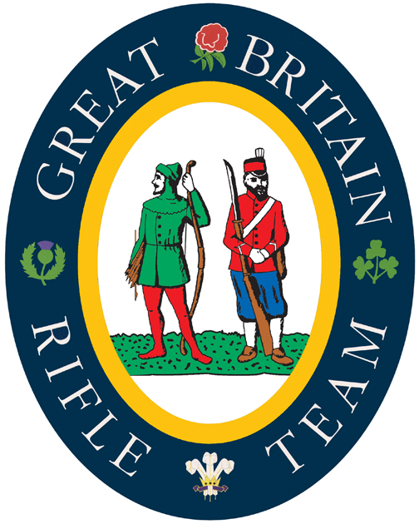
Kolapore 2025

Captain : John Bloomfield
Adjutant : Oliver Spencer
Main Coach : Jeremy Langley

The Team to represent Great Britain in the Kolapore Match 2025 will be selected from :

Target Coaches

Seth Dowley Matt Ensor Derek Lowe Graham Nelson Bill Richards

Firers

David Armstrong Glyn Barnett Nigel Ball Will Broad
Matt Button Hannah Cook Toby Cubitt Theo Dodds
Tom Drysdale Chloe Evans Rosanne Furniss Alice Good
Jemima Hince David Luckman Matt Millar Chris Mitchell
Luca O'Flynn Parag Patel Toby Raincock Tom Shaw
Rick Shouler Jon Underwood Sandy Walker John Warburton
Chris Watson James Watson

This list is not exclusive and so does not preclude others from selection based on scores during the Imperial Meeting.

Whilst not obligatory it would greatly assist the selection process - and your chances of selection (!) - if all potential firers could file their scores using Tracer by following the links and instructions below :

To download TRACER, please contact Oliver Spencer direct via email tracer@tracershooting.com. He will send you a link and password to download the App. The page will guide you through the download process for whichever platform you choose to use (iOS, Android or Windows). If you have not used the service before, once the app is downloaded, you will need to register for the service using the button on the login screen.

If it's the first time you have entered a scorecard, please watch the instructional video, a link to which is at the top of the download page. If you have any questions after following these instructions, please contact tracer@tracershooting.com.

Once downloaded, or if you already use the platform, please join the 'Kolapore Long List' by going to 'Profile' and 'Group shares' from the main screen. This will share your scorecards over the past year with Kolapore management.

