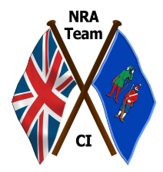
National Rifle Association
Channel Islands Tour 2024

I am delighted to announce those selected to represent the National Rifle Association in the Channel Islands in 2024.
I am very grateful for the support, interest and encouragement shown by all those who applied, and I wish them well in the future.

Captain: Liam Cheek London, Ireland, GB
Vice-Captain: Rebecca Laird Ulster, Ireland
Adjutant: Martin Liversage Lancashire, England, GB

George Bramwell Lancashire
David Colegate Gloucestershire
Katherine Fleck Yorkshire, England
Kerrie Johnson Ulster, Ireland
Michael Larcombe Lancashire
William Livesey Ulster, Ireland
Christopher Pawlik Hampshire
Sophie Ponter East of Scotland, Jersey, Channel Islands
Philippa Purdy North Hants, Leicestershire & Rutland, Wales
Henry Waldern England
Jonny Wallace Ulster, Ireland

Reserves:
Matthew Blythe Gloucestershire
Michael Rewston Nottinghamshire
Charlotte Wiltshire Cambridgeshire

Liam Cheek, Captain

