WA1500 EUROPEAN CHAMPIONSHIPS
RESULTS TABLES
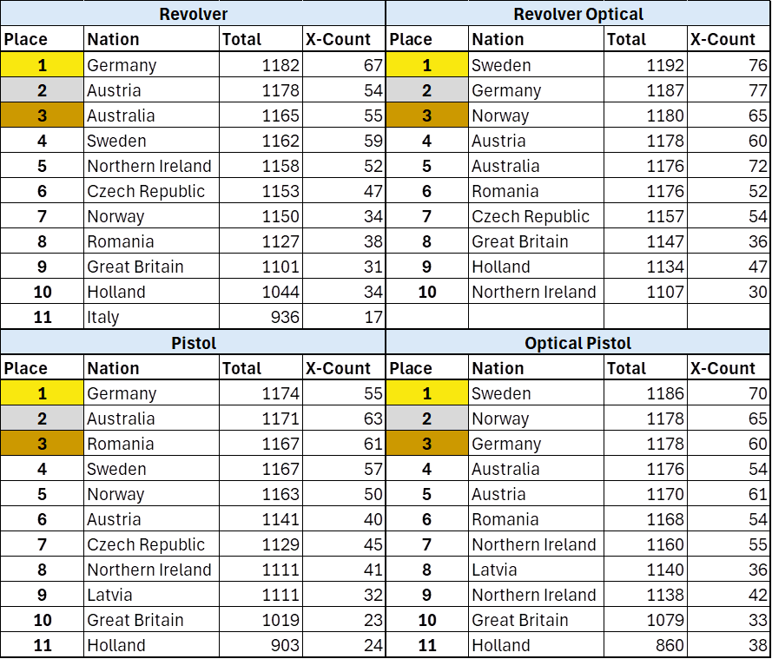

GREAT BRITAIN HANDGUN TEAM
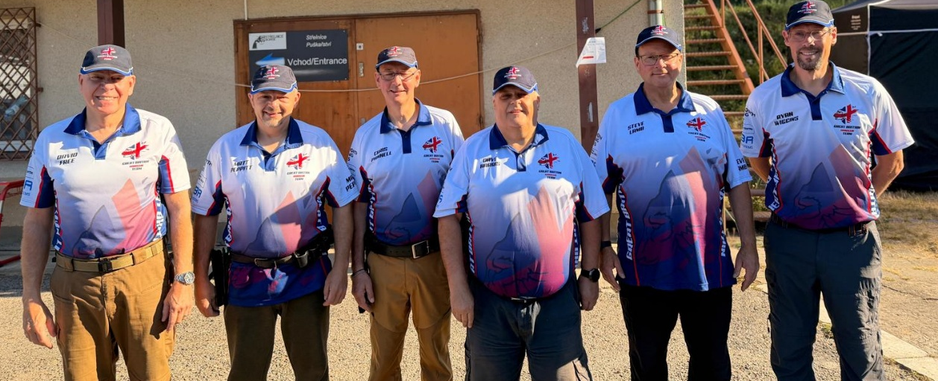
Left to Right: David Free (Adjutant), Matt Peppitt, Chris Pannell, Dave Harris (Captain)
Steve Lamb, Ryan Wiggins.

